□ nlayer = 4, nhead = 8, train_test_split = 0.973, input = 128, output = 10, epochs = 2000

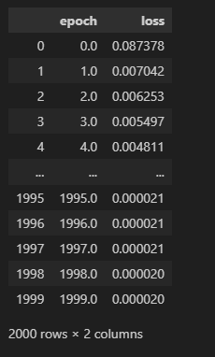

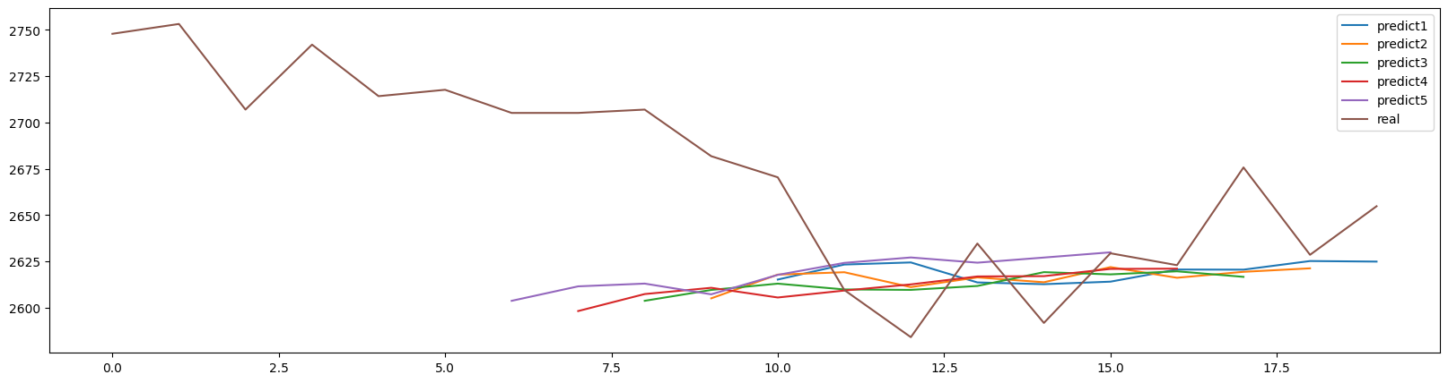

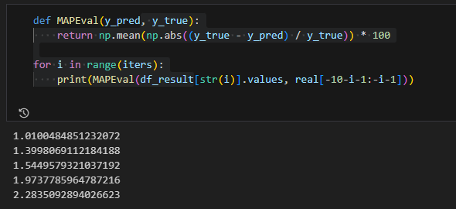

□ nlayer = 8, nhead = 8, train_test_split = 0.973, input = 128, output = 10, epochs = 500

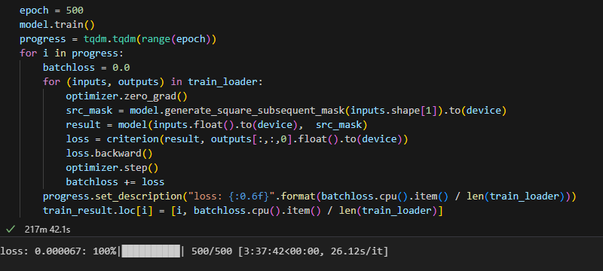

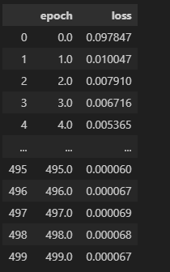

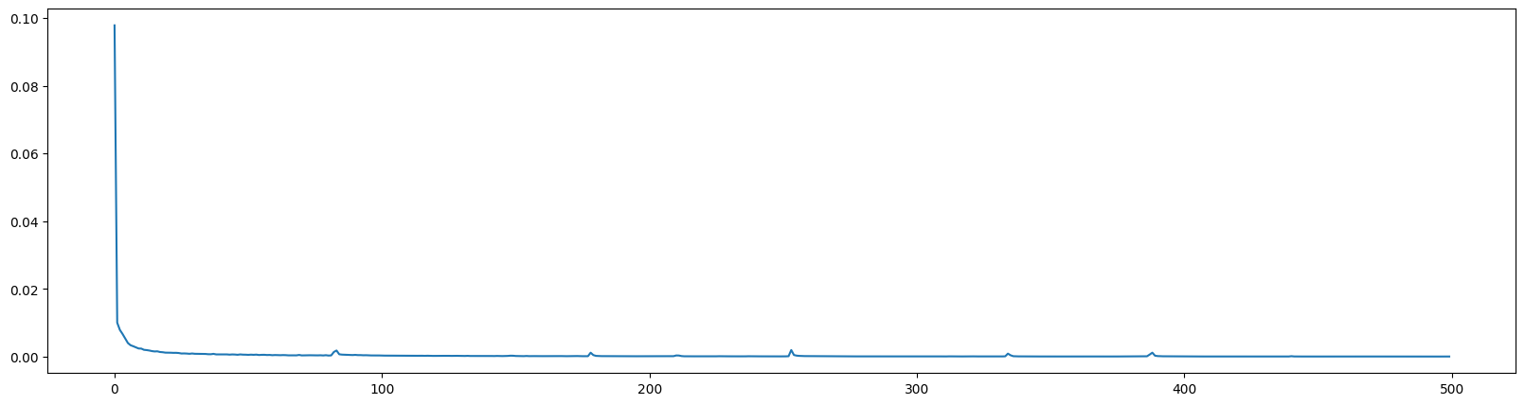

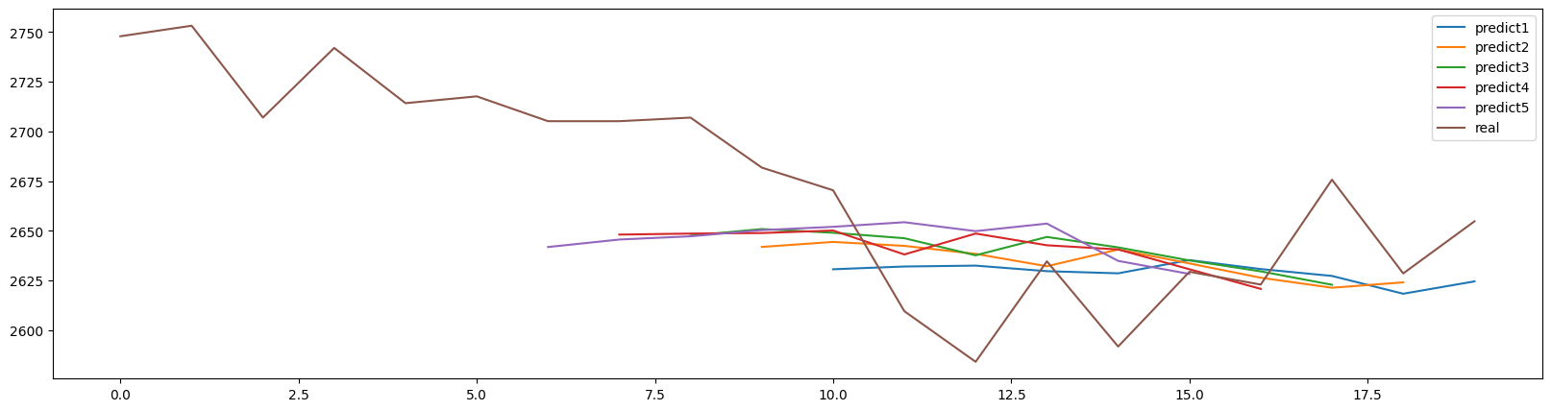

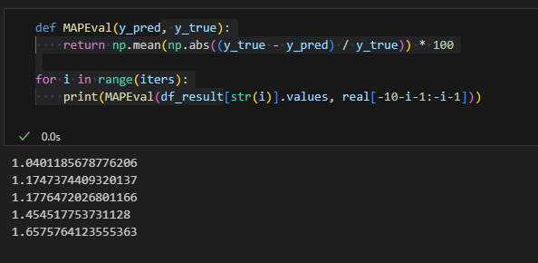

□ nlayer = 8, nhead = 8, train_test_split = 0.973, input = 128, output = 1, epochs = 100

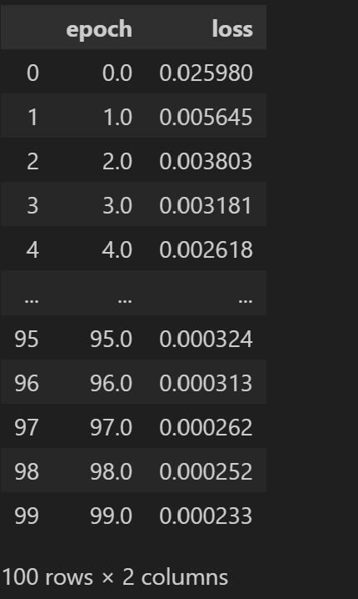

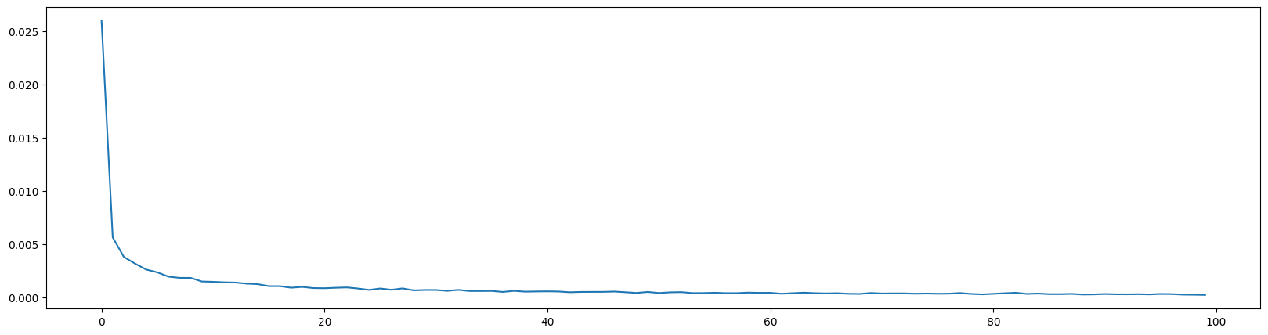

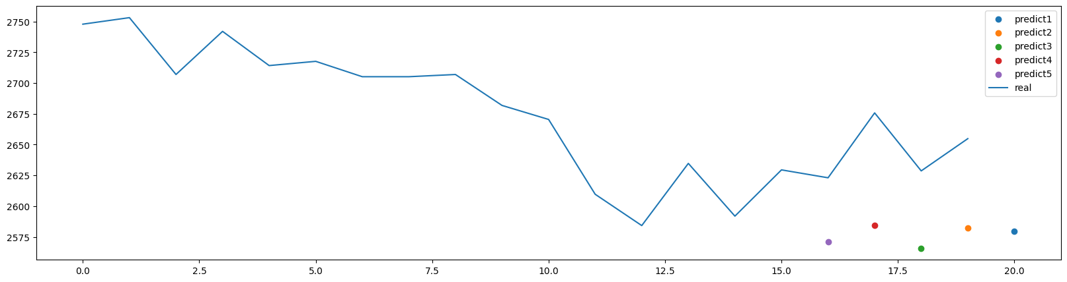

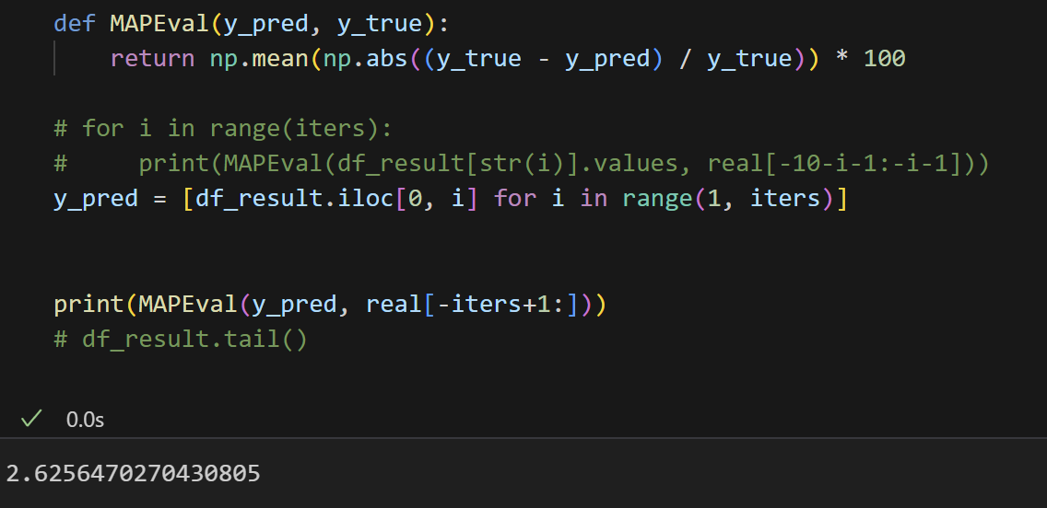

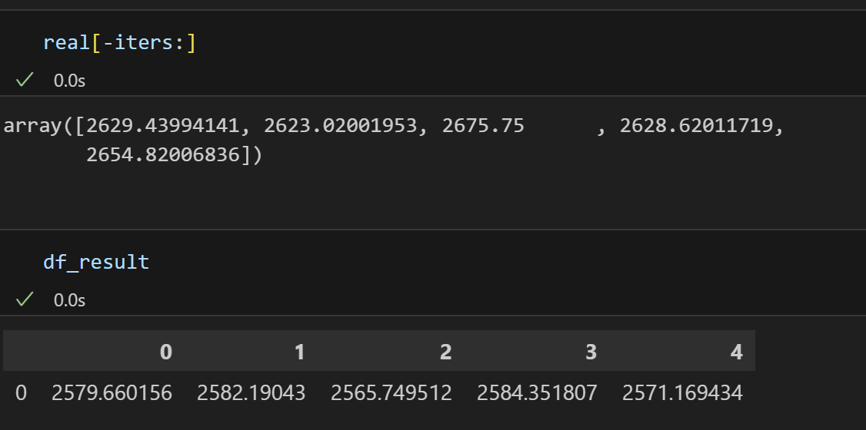

□ nlayer = 12, nhead = 4, train_test_split = 0.973, input = 128, output = 1, epochs = 100

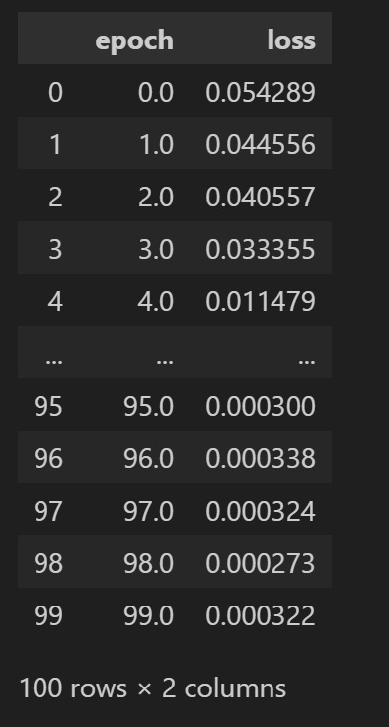

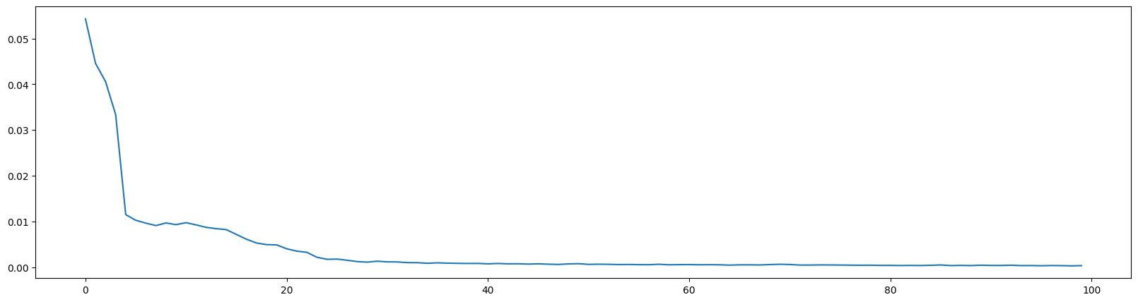

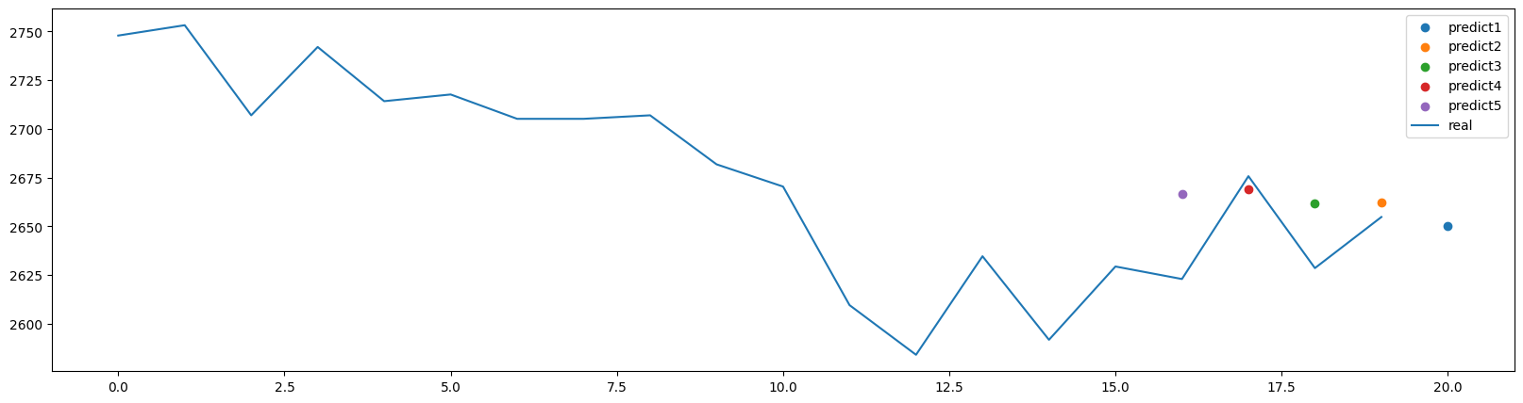

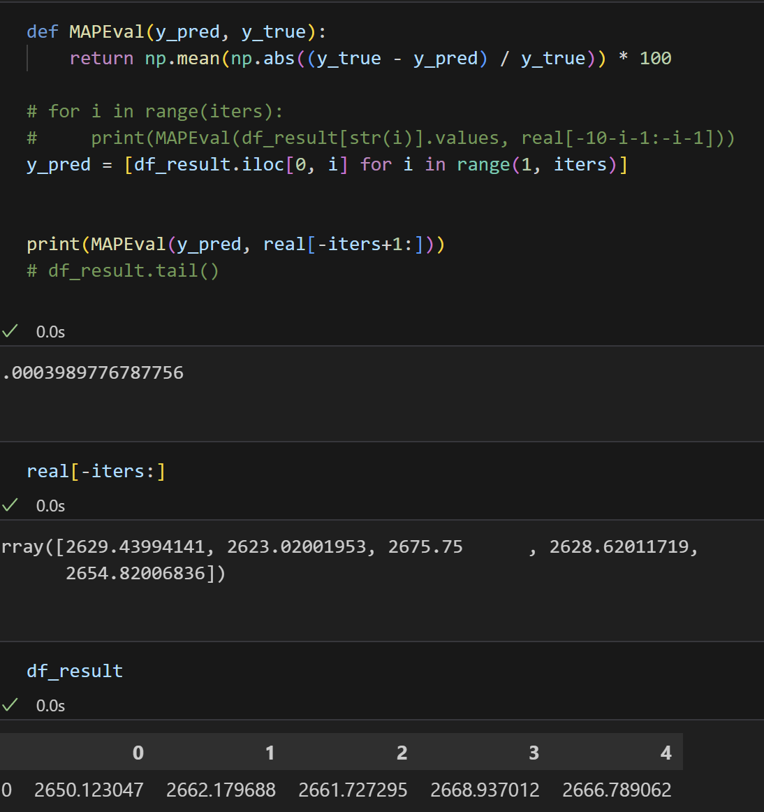

□ nlayer = 12, nhead = 8, train_test_split = 0.973, input = 128, output = 1, epochs = 200

